UPPWISE INDIA

www.uppwise.com



**Quaterly Development Planning**

**Q4-2023**

**Feature Title:**

Separate login links in the email

**Priority:**

High

**Submitted By:**

SPM

**Target Users:**

Standard SPM User + Customer (Bancasella)

**Feature Description:**

Single Sign-On (SSO) is a centralized authentication process that allows users to access multiple applications with a single set of credentials. In contrast, without SSO, users have to authenticate separately for each application.

When a user clicks on SSO link one, they will be redirected to the SSO login page, where they need to enter their credentials. After submitting the credentials, the user will be redirected back to our application, which will then authenticate whether the user is eligible for access. If the user authentication is successful, the application will further redirect the user to the requested page.

**Acceptance Criteria:**

I kindly request you to divide this variable in two separate ones:

* login with SSO
* login without SSO

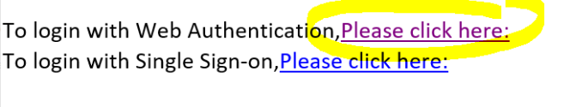

**Additional Comment:**